**Triangles** are 3-sided polygons.

**A**, **B**, and **C** are the 3 corner angles of the triangle. You can express them in degrees or radians. Angles must be positive and the sum of all 3 must equal 180 degrees.

**a**, **b**, **c** are the lengths of 3 sides of the triangle.

**Circumference** is the distance around the outside of the triangle, a + b + c.

**Area** is the area inside the triangle.

**Height** (marked h in the diagram) is the height from side a to corner A.

**Median** (marked m in the diagram) is the distance from the middle of side **a** to corner **A**.

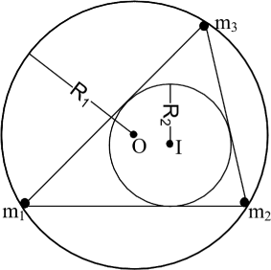

**Inradius** (R2 above) is the radius of the circle that fits inside the triangle and just touches each of the 3 sides.

**Circumradius** (R1 above) is the radius of the circle that runs through all three corners of the triangle.